- Mv:- The mv command in Linux is used to move or rename files and directories.
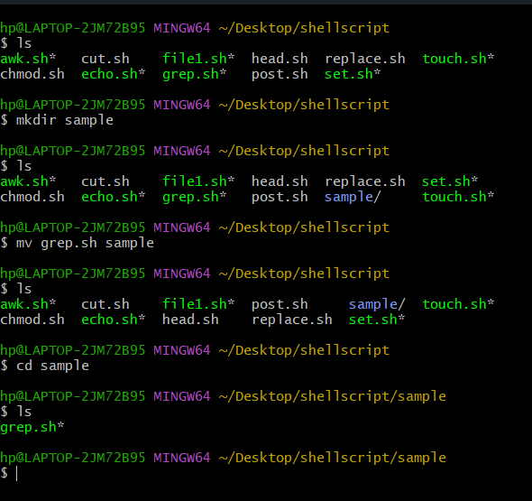
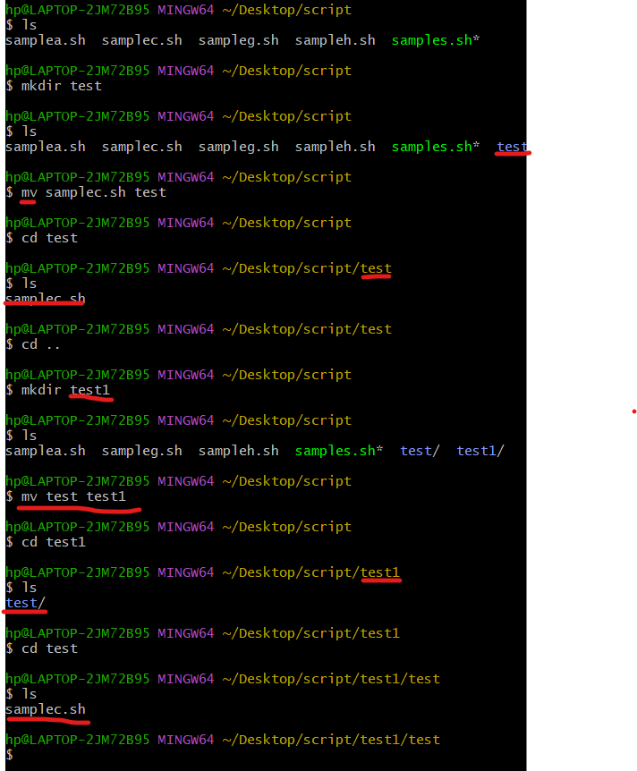
syntax:--mv [options] source destination-

- Grep: The grep command in Linux is a powerful tool for searching text.
- Options:
  - -i: Ignore case (e.g., grep -i "pattern" filename).
  - -r: Recursively search directories (e.g., grep -r "pattern" /path).
  - -v: Invert match, show lines that do NOT match (e.g., grep -v "pattern" filename).
  - -n: Show line numbers (e.g., grep -n "pattern" filename).
  - -l: Show filenames with matches (e.g., grep -l "pattern" *).
  - -c: Count matching lines (e.g., grep -c "pattern" filename).
Ex:-- grep "pattern" filename
This searches for the "pattern" in the specified filename.

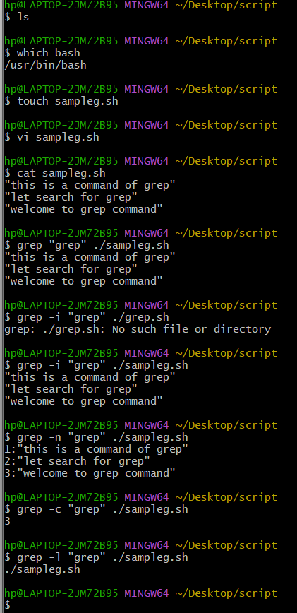

- Awk :-- The awk command in Linux is a powerful text-processing utility. It's used to search, filter, and manipulate text files. Here’s a quick rundown:
- Basic Syntax:
bash
Copy
awk 'pattern {action}' filename
- Fields: Text is divided into fields, accessed using $1, $2, etc.
bash
Copy
echo "Hello World" | awk '{print $2}'
Output: World
- Patterns: You can use patterns to match lines.
bash
Copy
awk '/pattern/ {action}' filename
- Actions: Common actions include print, mathematical operations, and more.
bash
Copy
awk '{print $1, $3}' filename
- Built-in Variables: Variables like NR (record number), NF (number of fields) are useful.
bash
Copy
awk '{print NR, $0}' filename
Here’s an example:
bash
Copy
awk '{print $1, $2}' file.txt
This command prints the first and second fields of each line in file.txt.
awk is like a Swiss Army knife for text processing. Want to see a specific example in action?
- Cat> :--
The cat command in Linux concatenates and displays file contents. When combined with the > operator, it redirects the output to a file. Here’s how it works:
cat > filename.txt
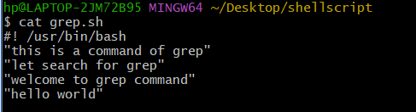

- Awk:-- F option in awk is used to specify the field separator. By default, awk uses whitespace (spaces or tabs) as the field separator, but you can change it with -F.

For example, if you have a CSV file data.csv with the following content:
Ex:--
Alice 30
Bob 25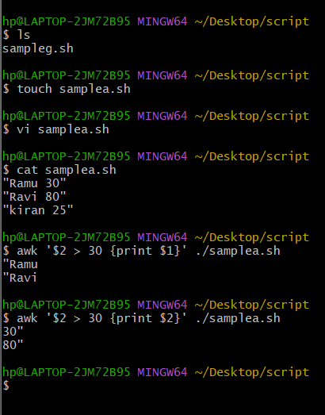
Charlie 35
Diana 40
Here's an example of using awk to print the names of people older than 30:
awk '$2 > 30 {print $1}' data.txt
Explanation:
- $2 > 30: This checks if the second field (age) is greater than 30.
- {print $1}: If the condition is true, it prints the first field (name).

This will output:
Charlie
Diana

- Cut -
The cut command in Linux is used to extract sections from each line of input, typically from text files or command output. It's especially handy for handling delimited data. Here’s a quick rundown:
Basic Usage:
cut [options] filename
Options:
- -d: Specify the delimiter (default is Tab).
- -f: Specify the field(s) to cut.
- -c: Specify the character position(s) to cut.
Ex:1 echo "Alice,23,Female" | cut -d',' -f1
Output: Alice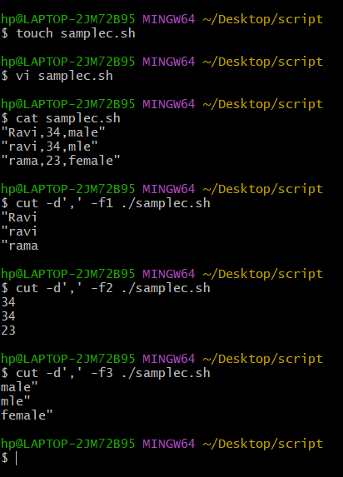
Ex:2 echo "Alice,23, Female" | cut -d',' -f1,3
Output: Alice,Female
Ex:3 Hello, World!
Welcome to Linux.
Happy scripting!
Q: cut -c1-5 textfile.txt
A: Hello
Welco
Happy
- Sort :--
Syntax: sed [options] 'command' input_file

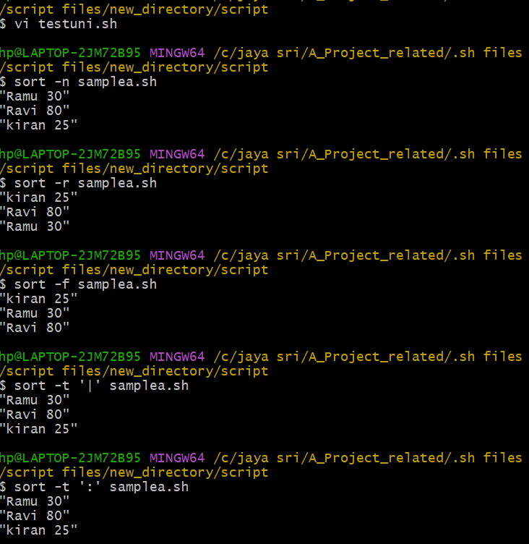

Common Options:

1. -e : Execute multiple commands.
2. -f : Read commands from file.
3. -i : Edit file in-place.
4. -n : Suppress automatic printing.
5. -r : Use extended regular expressions.

Commands:
1. p : Print line.
2. d : Delete line.
3. s : Substitute text.
4. y : Translate characters.
5. a : Append text.
6. i : Insert text.
7. c : Change text.

- Echo :-- it is simply print statement. It works simple print statement.
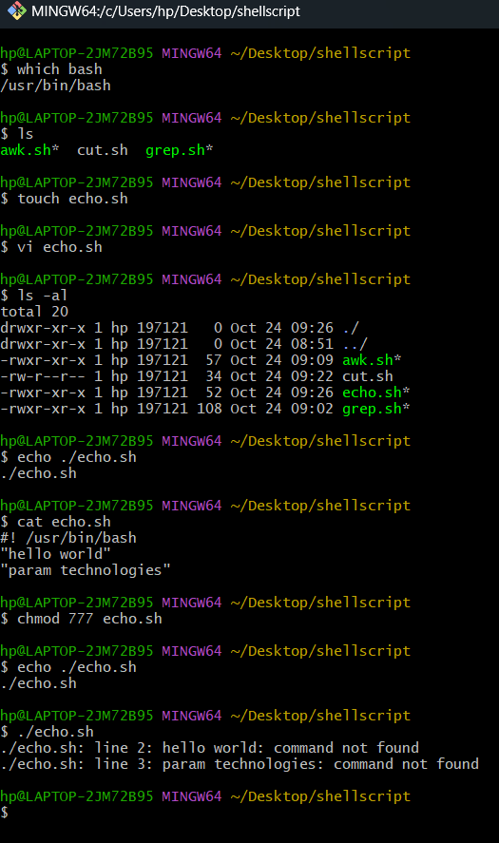
- Head -n1:--
The head -n 1 command in Linux is used to display the first line of a file. Here’s a quick example:
Suppose you have a file named example.txt with the following content:
Line 1: Hello, World!
Line 2: Welcome to Linux.
Line 3: Happy scripting!
By running:
Ex1:--head -n 1 example.txt
You'll get: Line 1: Hello, World!

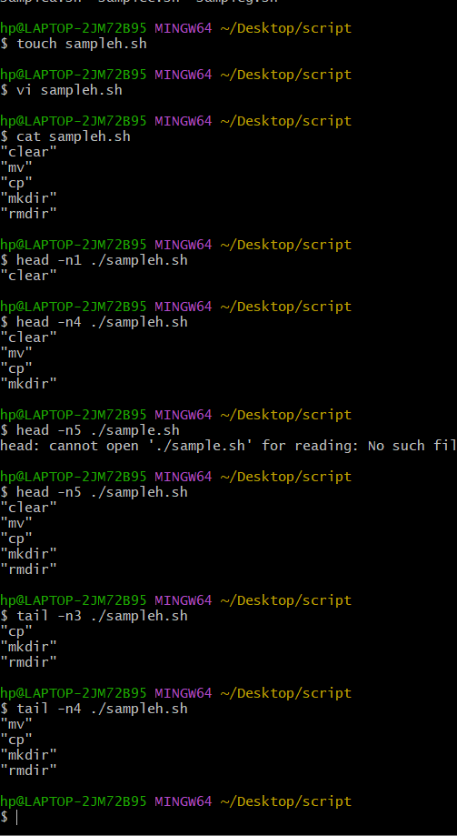

- Tail -n1:-- The tail -n 1 command in Linux is used to display the last line of a file. Here’s an example:
Suppose you have a file named example.txt with the following content:
Line 1: Hello, World!
Line 2: Welcome to Linux.
Line 3: Happy scripting!

By running:
tail -n 1 example.txt
You’ll get:--Line 3: Happy scripting!
Sed s :---
The sed command is a powerful stream editor in Linux, and the s command within sed is used for substitution.
Basic Syntax
sed 's/pattern/replacement/' file
Example
Suppose you have a file named example.txt with the following content: 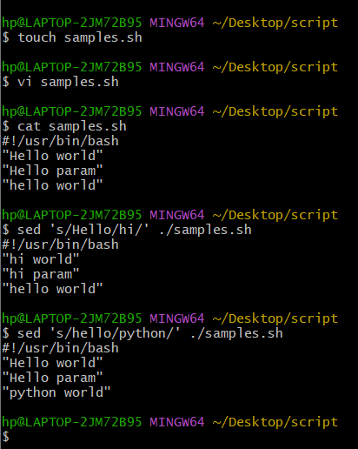
Hello, World!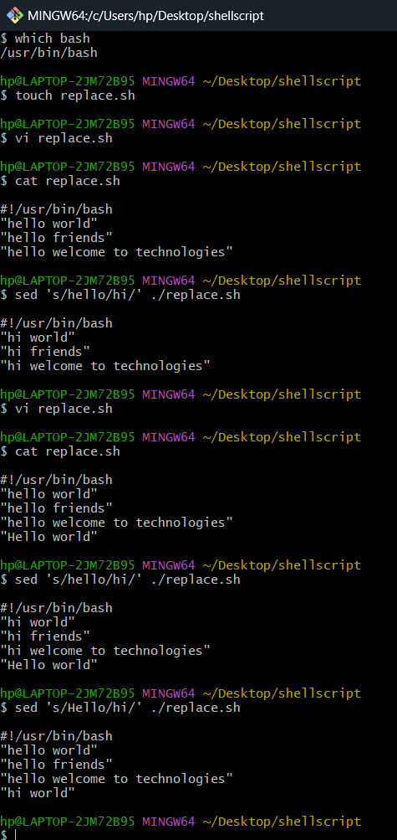
Welcome to Linux.
This is a sample text.

Ex2:-- To replace the word "Hello" with "Hi":
sed 's/Hello/Hi/' example.txt

output :-- Hi, World!
Welcome to Linux.
This is a sample text.

- Fi:--The fi command is used to close an if statement in shell scripting. It's essentially the end keyword for an if block.
if [ -f "example.txt" ]; then
echo "File exists."
else
echo "File does not exist."
fi
In this script:
- if starts the conditional block.
- [ -f "example.txt" ] checks if example.txt is a file.
- then executes the commands that follow if the condition is true.
- else executes the commands if the condition is false.
- fi closes the if block.

- Chmod :-- The chmod command in Linux is used to change the access permissions of files and directories.
chmod [options] mode file
Modes
- Numeric (Octal) Mode: Sets permissions using three digits representing user (owner), group, and others.
  - 7 = read (4) + write (2) + execute (1) = 7
  - 6 = read (4) + write (2) = 6
  - 5 = read (4) + execute (1) = 5
  - 4 = read (4) = 4
  - Example: chmod 755 file.txt
Ex: chmod 755 script.sh
This sets the file script.sh to be readable and executable by everyone, and writable by the owner.

- Post -h
I'm assuming you might be referring to the curl -X POST command, which is often used to send POST requests to a server. The -H option is used to specify headers. Here's an example to illustrate:
bash
Copy
curl -X POST -H "Content-Type: application/json" -d '{"name":"John", "age":30}' https://api.example.com/users
In this example:
- -X POST: Specifies the request method as POST.
- -H "Content-Type: application/json": Adds a header indicating that the data being sent is in JSON format.
- -d '{"name":"John", "age":30}': Specifies the data to be sent in the POST request.
- https://api.example.com/users: The URL to which the request is sent.
This sends a JSON object with a name and age to the specified API endpoint. Give it a shot, and let me know how it goes!

- Set -x
The set x command in a shell script is a debugging tool that prints each command to the terminal as it is executed. This is useful for tracing the flow of execution and finding bugs in your scripts.

Ex:
echo "Starting script"
VAR=5
echo "VAR is $VAR"
output: Starting script
VAR is 5

How to write for loops in shell script:---
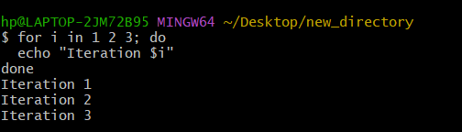
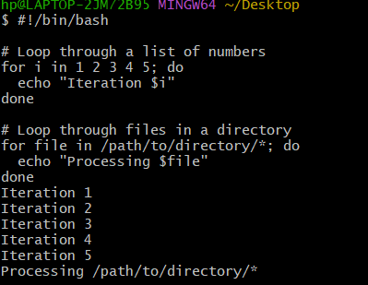

How to write conditions
$if [ “$name” == “Alice” ]; then
Echo “hello, Alice!”
Else
Echo “hello, stranger!”
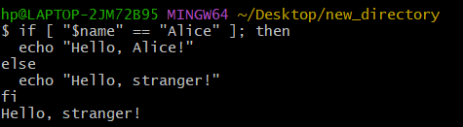
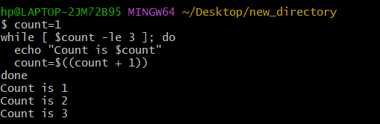
Write a function using sh commands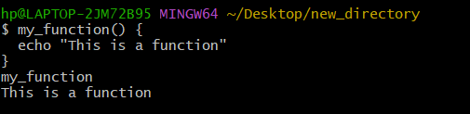
Difference of two files data:--

Cat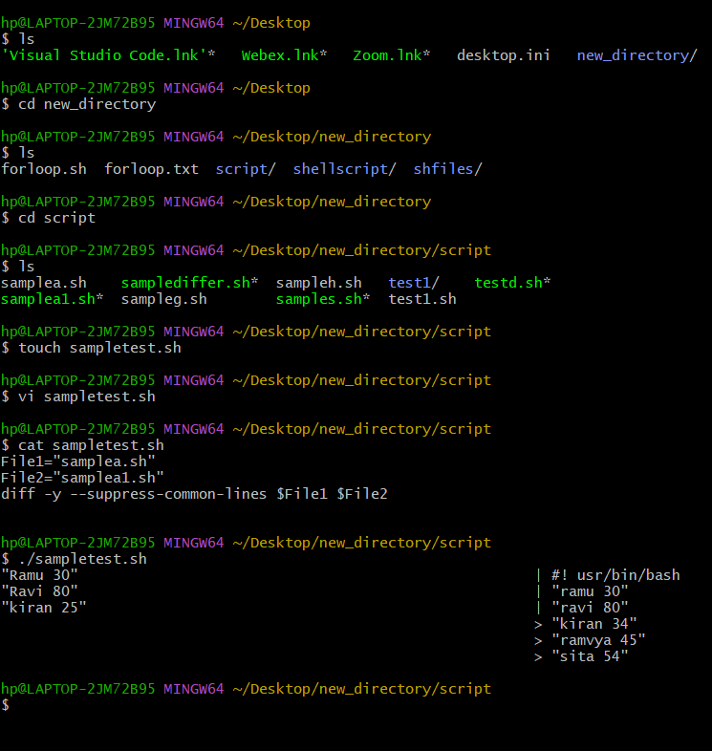
Vimdiff :
Syntax:-- vimdiff file2.sh file2.sh
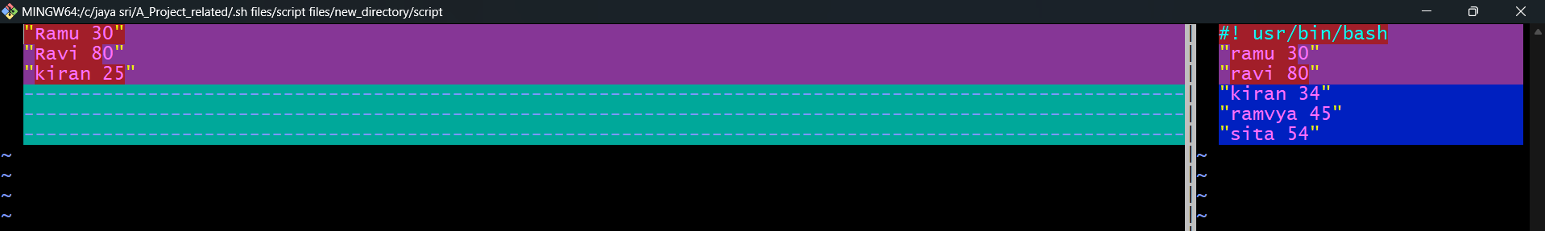

Comm:--
